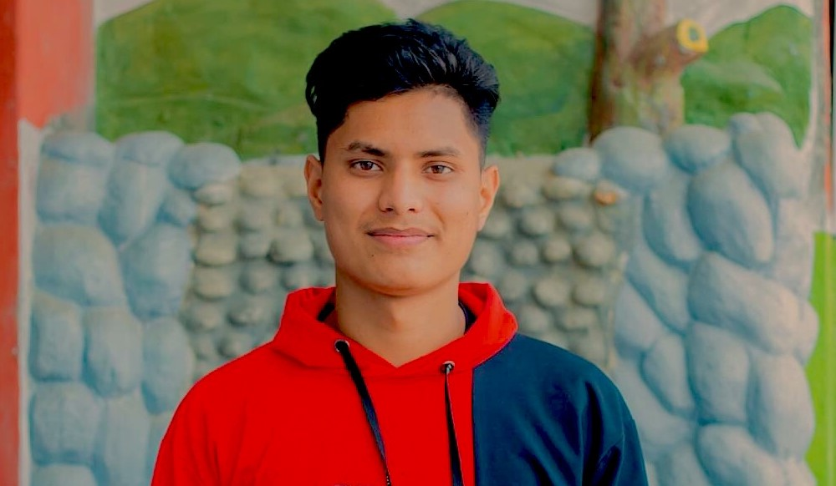

WORK EXPERIENCE

ABOUT ME

I am a CS student studying Computer Science and Information Technology (CSIT). In current role I am in First semester of my current bachelor studies. And searching for a suitable part time jobs like web developing and programming.

BIBEK GHIMIRE

WEB DEVELOPER

Bibek Ghimire

EDUCATION

**B.Sc. CSIT**

Nepalaya College

Kalanki Kathmandu

**+2 Science**

REHDON

Samakhushi Kathmandu

**Secondary Level Education**

New West Point

Beni Myagdi

|  |  |  |
| --- | --- | --- |
| **Position & Company Name** | **Key responsibilities and achievements** | **Years** |
| Web Developer  *ABC Nepal* | Beginner software developer. 6 month experience and concept of basic web development. And knowledge of HTML, CSS, JavaScript and PHP | 2021 - date |
| App Developer  *XYZ Revolution* | Android Beginner app Developer.  ! Year experience with RS 1L annual budget.  And basic ideas of flutter, .NET and python. | 2020 - 2021 |

REFERENCE

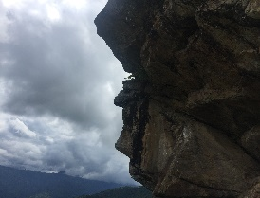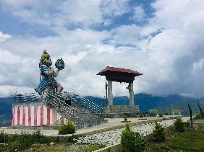

**ADDRESS**

Beni Myagdi Nepal

**WEBSITE**

bibekghimire1.com.np

**Phone**

9805116277

**EMAIL**

binekghimire555@gmail.com

**ABC NEPAL**

Android App Developer

**KODE STAGE**

Web Developer

**XYZ REVOLUTION**

Programmer

PHOTOGRAPHS